
Table of Contents
- Introduction
1.1 Project Overview
1.2 Objectives
- Requirements Specification
2.1 Functional Requirements
2.1.1 Book Management
2.1.2 Member Management
2.1.3 Loan Management
2.1.4 Book Club Management
2.1.5 User Authentication
2.2 Non-functional Requirements
2.2.1 Performance
2.2.2 Security
2.2.3 Reliability
2.2.4 Usability
2.2.5 Maintainability
2.3 Database Requirements
2.4 Business Rules
2.5 Constraints
- Database Design
3.1 Tables & Relationships
3.2 Relationships
3.3 Key Database Rules
3.4 Summary
3.5 ER Diagram
- SmartLibrary Code Structure & Functionality
4.1 models.py – Core Classes
4.2 Database Connectivity
4.3 Author Management
4.4 Book Management
4.5 Member Management
4.6 Loan Management
4.7 Book Club Management
4.8 User Authentication
4.9 PyQt5 GUI
4.10 Main Function
4.11 Key Features & Business Rules Enforced
- Challenges & Solutions
- Conclusion

1. Introduction
The SmartLibrary project focuses on building a digital library system for Limkokwing University. The goal is to replace several manual processes that currently slow down daily library operations. After conducting an interview with the university’s library staff, three main issues became clear:
• Weak security around book borrowing and member verification
• Limited automation in recording and managing library activities
• Poor tracking of books, returns, loan history, and overdue items
These problems cause delays, errors, and loss of library resources. Our project responds to these challenges with a system that uses Python and PostgreSQL to automate the library’s core tasks while improving accuracy and accountability.
The SmartLibrary application is designed as a desktop-based system with a structured backend that manages all library data. The database stores information about books, authors, members, book clubs, and loans. The Python backend uses object oriented programming to apply business rules, validate user actions, and connect the interface to the database. A PyQt5 GUI gives librarians and members a simple way to interact with the system.
The main objectives of the system are:
• Improve the security of borrowing and returning books through controlled user access
• Automate record keeping to reduce manual errors
• Track book availability, loan status, overdue records, and member limits
• Provide clear interfaces for searching books, managing members, and organizing book clubs
The application is designed to support both librarians and regular members. Librarians can manage all records, while members can search for books and access their personal loan details. Every action interacts directly with the PostgreSQL backend to maintain accurate and up to date information.

2. Requirements Specification
The requirements for the SmartLibrary system come directly from the problems discovered during the interview with the Limkokwing University library staff. Since the introduction highlights weak security, limited automation, and poor tracking, every requirement below is designed to remove those weaknesses and create a faster, more accurate, and controlled library environment.

2.1 Functional Requirements
2.1.1 Book Management
The system must handle all book information in a way that eliminates manual errors and improves tracking. It must:
• Store complete details for each book including ISBN, title, author, genre, and number of copies.
• Track available copies instantly to prevent confusion about which books are still in the library.
• Block borrowing when a book has no copies available.
• Update availability as soon as a loan is created or returned.
This aligns with the introduction’s goal of improving record accuracy and removing manual updates.

2.1.2 Member Management
To reduce verification problems and human mistakes, the system must:
• Register members with unique IDs.
• Store names, emails, and defined roles such as student, librarian, or admin.
• Count how many books each member has borrowed.
• Enforce the rule that a member cannot borrow more than three books at once.
This supports the introduction’s aim of securing borrowing processes and improving accountability.

2.1.3 Loan Management
To automate tracking and remove delays caused by manual recording, the system must:
• Record each loan with member ID, ISBN, date borrowed, due date, and return date.
• Automatically mark loans as overdue when due dates pass.
• Adjust book availability when loans are made or returned.
• Prevent a member from borrowing the same book twice without returning it.
This connects directly to the introduction’s problem of poor tracking of loan history and overdue items.

UML :
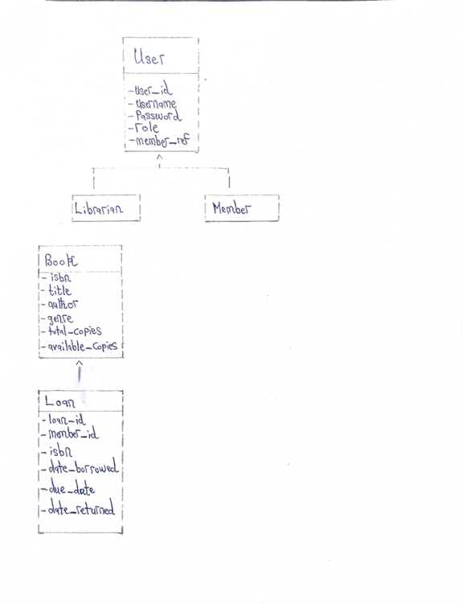
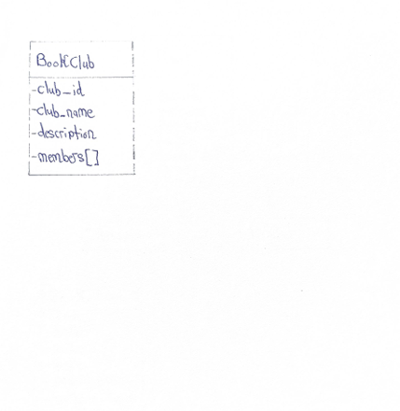

2.1.4 Book Club Management
The system must:
• Create and store book club information.
• Assign members to clubs.
• Allow librarians to view club membership lists.
This supports the introduction’s point about offering organized and accessible records for all library activities.

2.1.5 User Authentication
Because weak security was one of the biggest issues identified, the system must:
• Store user credentials securely.
• Authenticate users reliably at login.
• Assign roles that control what each user can access.
• Link users to their member profiles when necessary.

Log in Wireframe sketch :
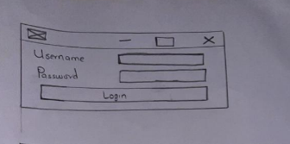

2.2 Non-functional Requirements
These requirements ensure the system remains secure, fast, reliable, and usable while supporting everyday library operations.
2.2.1 Performance
• Login should authenticate in under two seconds.
• Queries should load within three seconds even with large amounts of data.
This supports smooth daily operations, addressing delays mentioned in the introduction.

2.2.2 Security
• Passwords must be encrypted.
• Only authorized roles can edit sensitive records such as books or members.
• Students must not access restricted admin areas.
This reinforces the introduction’s goal of improving security and preventing unauthorized activity.

2.2.3 Reliability
• Loan records must remain safe and accurate.
• The system must maintain consistency even when multiple users work at the same time.
This supports the introduction’s focus on eliminating errors and data loss.

2.2.4 Usability
• The interface must be clear for librarians with minimal technical skills.
• The system must block invalid actions to reduce mistakes.
This directly improves the slow and error-prone manual processes mentioned earlier.

2.2.5 Maintainability
• Code structure must be clean and modular.
• Naming conventions and documentation must allow new developers to understand the system quickly.
This ensures long-term sustainability of the system.
Dashboard wireframe :
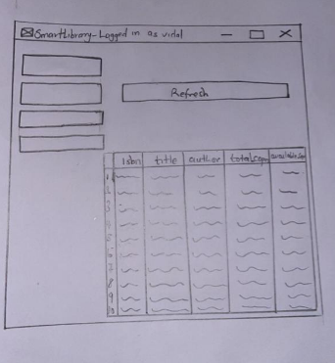

2.3 Database Requirements
To support the automated environment described in the introduction, the database must:
• Use PostgreSQL as the main storage engine.
• Include tables for books, members, authors, book clubs, loans, and users.
• Maintain relationships through foreign keys.
• Use triggers to automate updates such as adjusting available copies.
• Block deletion of records that still have active links, such as members with active loans.

2.4 Business Rules
Rules the system must enforce to maintain order and prevent abuse:
• Members can borrow up to three books at a time.
• Loans become overdue when the due date is passed and not returned.
• Books with zero available copies cannot be borrowed.
• Only librarians or admins can register new members or books.
• Usernames must be unique.
• Members cannot borrow the same book twice before returning it.
These rules remove the lack of structure that currently leads to disorganization.

2.5 Constraints
• The system is built with Python and PyQt5 for the interface.
• PostgreSQL is used for backend data storage.
• University devices and network may be slow, so the system must remain lightweight.
3. Database Design
The database design of the SmartLibrary system forms the backbone of the application, supporting all library operations securely, accurately, and efficiently. It ensures that books, members, loans, book clubs, and users are properly tracked, while enforcing the business rules defined in the requirements. The system uses PostgreSQL as the backend for reliable storage, relationships, and query performance.

3.1 Tables & Relationships
The database contains several core tables, each representing a key entity in the library system:
• authors
o Stores details about book authors.
o Columns: author_id (Primary Key), name (Unique)
o Purpose: Ensures each author is unique and links books to their authors.
• books
o Stores information about each book in the library.
o Columns: isbn (PK), title, author_id (FK → authors), genre, total_copies, available_copies
o Purpose: Tracks book inventory and availability. Links each book to a specific author.
• members
o Stores library members and their roles.
o Columns: member_id (PK), name, email, role
o Purpose: Manages members and enforces borrowing limits and role-based access.
• loans
o Tracks the borrowing and returning of books.
o Columns: loan_id (PK), member_id (FK → members), isbn (FK → books), date_borrowed, due_date, date_returned
o Purpose: Maintains a complete record of loans, including overdue detection.
• book_clubs
o Stores book club information.
o Columns: club_id (PK), club_name, description
o Purpose: Allows organization of members into book clubs for discussions and activities.
• member_clubs
o Junction table linking members to book clubs (many-to-many relationship).
o Columns: member_id (FK → members), club_id (FK → book_clubs)
o Purpose: Supports multiple members in multiple clubs while preventing duplicates.
• users
o Stores system login credentials.
o Columns: user_id (PK), username (Unique), password, role ('admin', 'librarian', 'member'), member_ref (FK → members, nullable)
o Purpose: Enables secure login and role-based access. Optional member_ref links users to members.

3.2 Relationships
• Books → Authors
o Each book is linked to exactly one author (one-to-many relationship).
• Loans → Members
o Each loan belongs to one member (many-to-one).
• Member_Clubs → Members & Book_Clubs
o Supports a many-to-many relationship between members and book clubs.
• Users → Members
o Users may optionally be linked to a member to enforce role-based functionality.
ER Diagram :

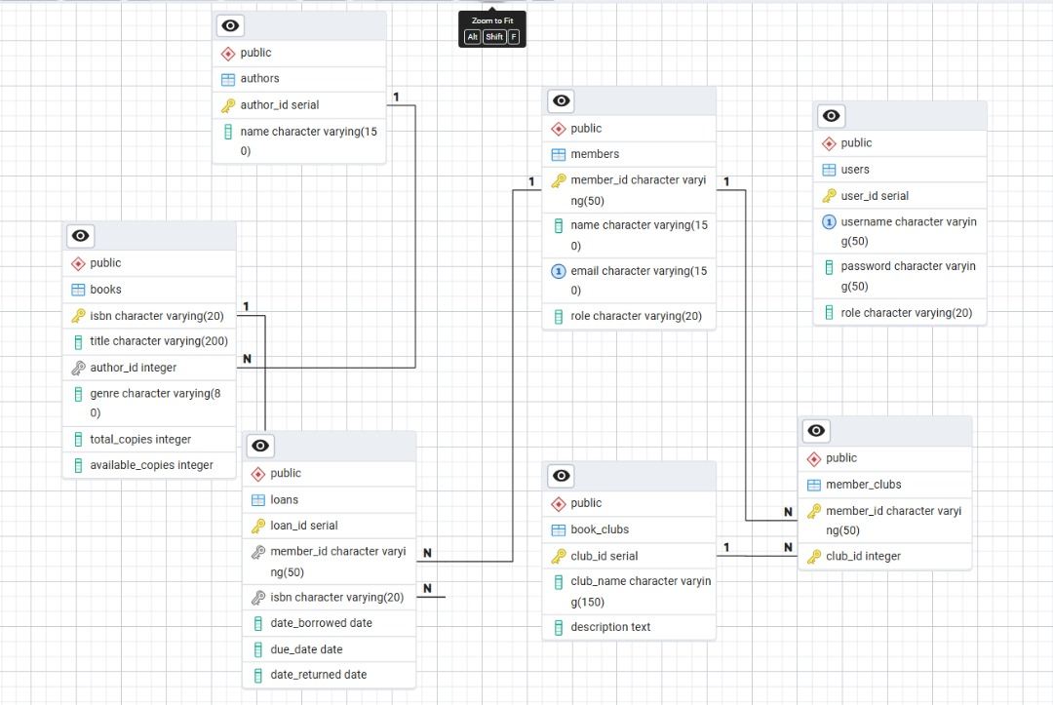

3.3 Key Database Rules
• A book cannot be borrowed if no copies are available.
• A member cannot borrow more than three books at a time.
• Books with active loans cannot be deleted.
• Loan records track borrowing and returning to prevent data loss.
• Foreign keys and constraints enforce relational integrity across tables.
3.4 Summary
The database design directly addresses the problems identified in the Introduction:
• Improves security by controlling access through the users table.
• Automates record-keeping for books, members, and loans.
• Provides clear tracking of book availability, loan history, and overdue items.
• Supports book clubs and many-to-many relationships efficiently.
This structure ensures that the SmartLibrary system can scale reliably while enforcing all business rules and providing accurate, real-time data for library operations.

4. SmartLibrary Code Structure & Functionality
This section explains the key Python code components of the SmartLibrary system, their purpose, and how they implement the library’s business rules and database interactions.

4.1 models.py – Core Classes
These classes represent the main entities of the library system. They store data in memory and implement basic business logic.
Book
• Attributes: isbn, title, author, genre, total_copies, available_copies
• Methods: is_available() – checks if at least one copy is available
• Purpose: Represents library books and allows checking availability before loans.
Member
• Attributes: member_id, name, email, role, borrowed_books
• Methods: can_borrow() – enforces a maximum of 3 borrowed books
• Purpose: Tracks member information and borrowed books.

Loan
• Attributes: loan_id, member_id, isbn, date_borrowed, due_date, date_returned
• Methods: is_overdue() – returns True if a loan is past due
• Purpose: Tracks borrowing activity and calculates overdue status.
BookClub
• Attributes: club_id, club_name, description, members
• Purpose: Manages book clubs and tracks member memberships (many-to-many relationship).
User
• Attributes: user_id, username, password, member_ref, role
• Purpose: Represents system login accounts, optionally linked to a Member, supporting roles like admin, librarian, or member.

4.2 Database Connectivity
• DB dictionary: Stores PostgreSQL credentials
• _get_conn(): Returns a connection using psycopg2
• Purpose: Standardizes database access for all CRUD operations.

4.3 Author Management
add_author(name)
• Checks if author already exists.
• Inserts a new author if not present and returns author_id.
• Purpose: Prevents duplicates and maintains author-book relationships.

4.4 Book Management
add_book()
• Links book to an author.
• Inserts with total and available copies.
• Prevents duplicate ISBNs.
update_book()
• Updates title, author, genre, or copies if provided.
• Ensures book exists before updating.
delete_book()
• Prevents deletion if active loans exist.
get_all_books() & search_books()
• Retrieves books with author info.
• Supports search by title or author.
Purpose: Implements full CRUD for books and enforces borrowing limits and availability rules.

4.5 Member Management
add_member()
• Registers members and avoids duplicates.
fetch_all_members() & get_member()
• Retrieves member details for display or validation.
Purpose: Maintains member data and ensures integrity.

4.6 Loan Management
borrow_book()
• Checks member existence.
• Enforces borrowing limit (max 3 books).
• Checks book availability.
• Inserts loan with a default 7-day due date.
return_book()
• Updates date_returned.
• Ensures only active loans are returned.
borrowed_view() & check_overdue()
• Retrieves all borrowed or overdue books.
Purpose: Enforces core borrowing/return rules, availability, limits, and overdue tracking.

4.7 Book Club Management
get_club_members(club_id)
• Lists members in a specific club.
add_book_to_club(member_id, club_id)
• Adds a member to a club, preventing duplicates.
Purpose: Supports many-to-many relationships between members and book clubs.

4.8 User Authentication
verify_user(username, password)
• Checks credentials (plain text in this version).
• Returns user ID, username, and role.
Purpose: Secures system access and distinguishes admin, librarian, and member roles.

4.9 PyQt5 GUI
LoginPage
• Simple login form.
• Calls verify_user and opens MainWindow on success.
AddBookPage & ShowBooksPage
• Add new books and display all books.
• Refresh button updates data from DB.
AddMemberPage & ShowMembersPage
• Add new members and display all members.
MainWindow
• Sidebar navigation.
• Uses QStackedWidget for page management.
• Table displays data dynamically.
Purpose: Provides an intuitive interface for librarians to manage books and members efficiently.

4.10 Main Function
• Starts PyQt5 application.
• Shows LoginPage first.
• Opens MainWindow personalized by user role on login.
Purpose: Entry point of the desktop application.

4.11 Key Features & Business Rules Enforced
• Members can borrow a maximum of 3 books.
• Books cannot be borrowed if no copies are available.
• Books with active loans cannot be deleted.
• Overdue books are tracked automatically.
• Users are linked to members and have role-based access.
• Book club membership is managed as a many-to-many relationship.

5. Challenges & Solutions
• Concurrent Access: Multiple users updating loans → used transactions & foreign keys
• Duplicate Entries: Prevented with UNIQUE constraints & validation in Python
• Role Enforcement: Implemented conditional checks in backend functions
• Overdue Tracking: Automated using database functions & Python checks

6. Conclusion
SmartLibrary automates library operations while enforcing business rules and security:
• Secures borrowing/returning with role-based access
• Automates book/member/loan tracking
• Enforces borrowing limits and availability rules
• Supports book clubs and reporting
The system is modular, maintainable, and scalable for future library needs.

